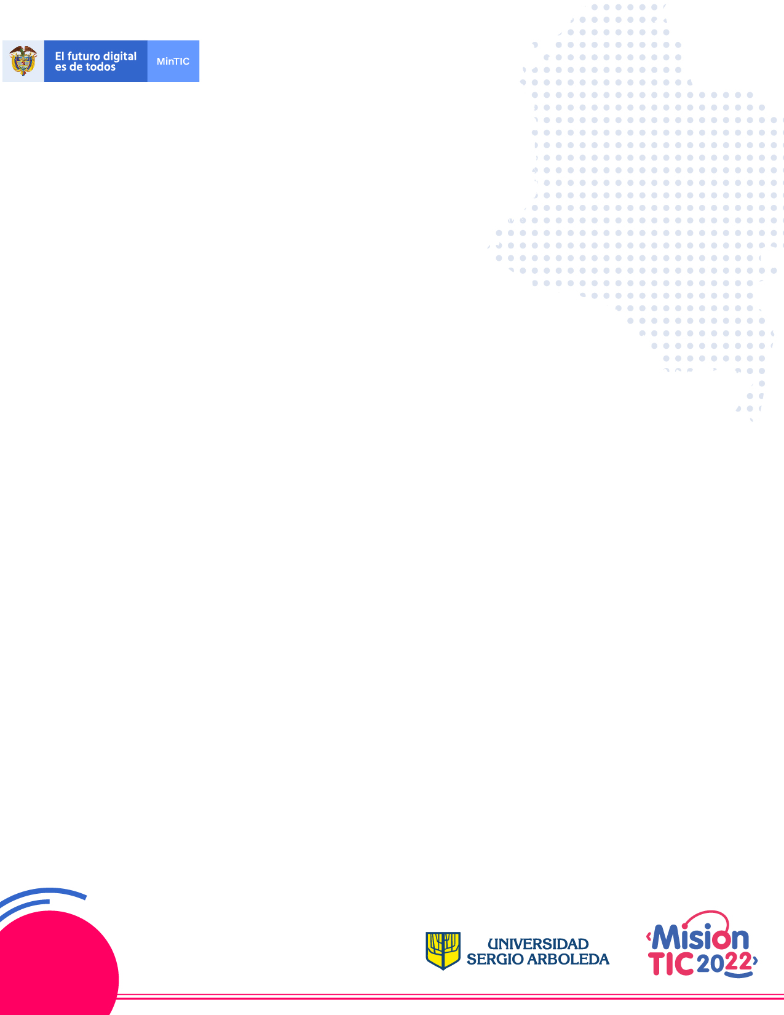

**Week 6 Class 1**

**Student Worksheet**

**Review**

**References:**

**New English File**

# **I. Review**

# **Grammar**

1. Work with your partner, and circle a, b or c.

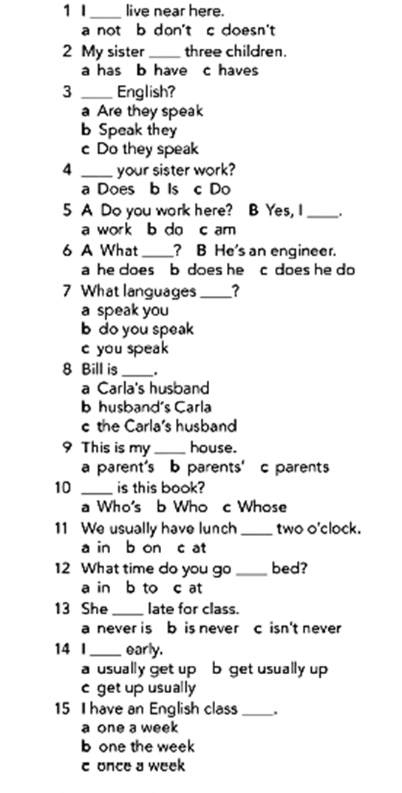

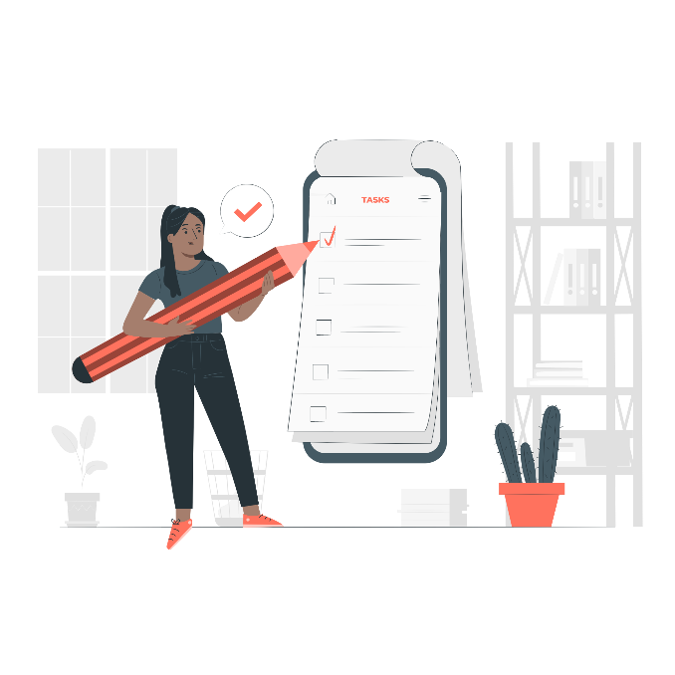

<a href="https://storyset.com/work">

Illustration by Freepik Storyset</a>

1. **Complete with at, in, on, to, or up.** Write down the correct option.

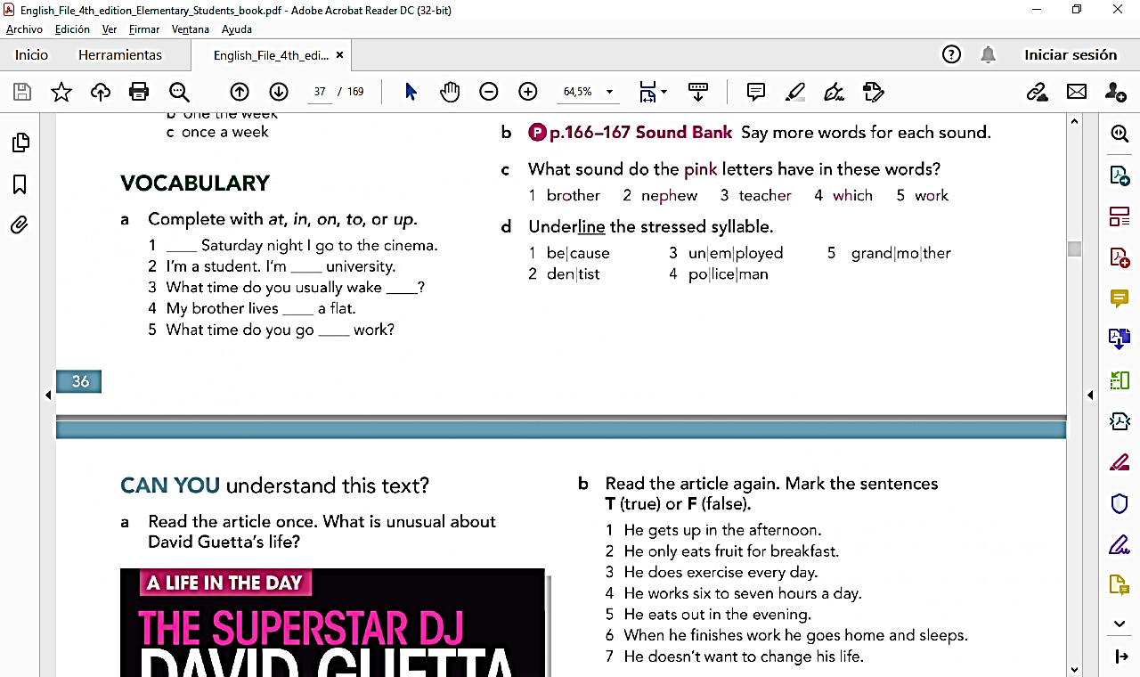

1. Complete the phrases with these verbs.

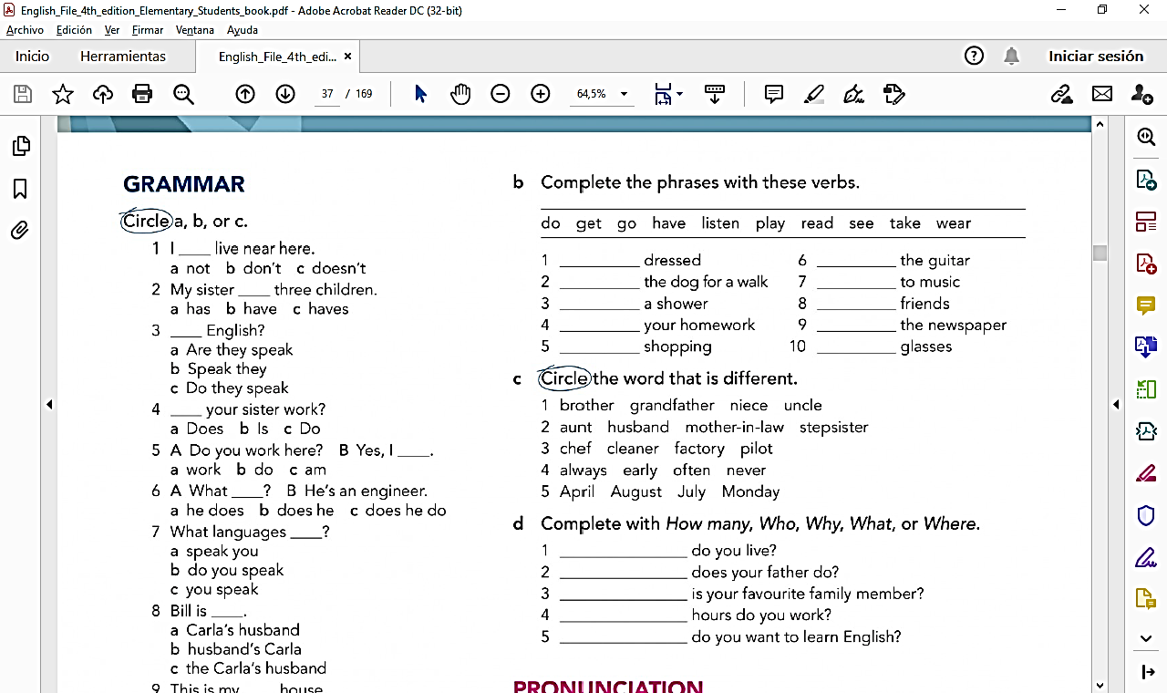

1. Circle the word that is different.



1. Complete with ***How many, Who, Why, What or Where.***



# **Listening**

1. **Can you understand these people?** Listen and answer the questions.

*\*Recording 1*

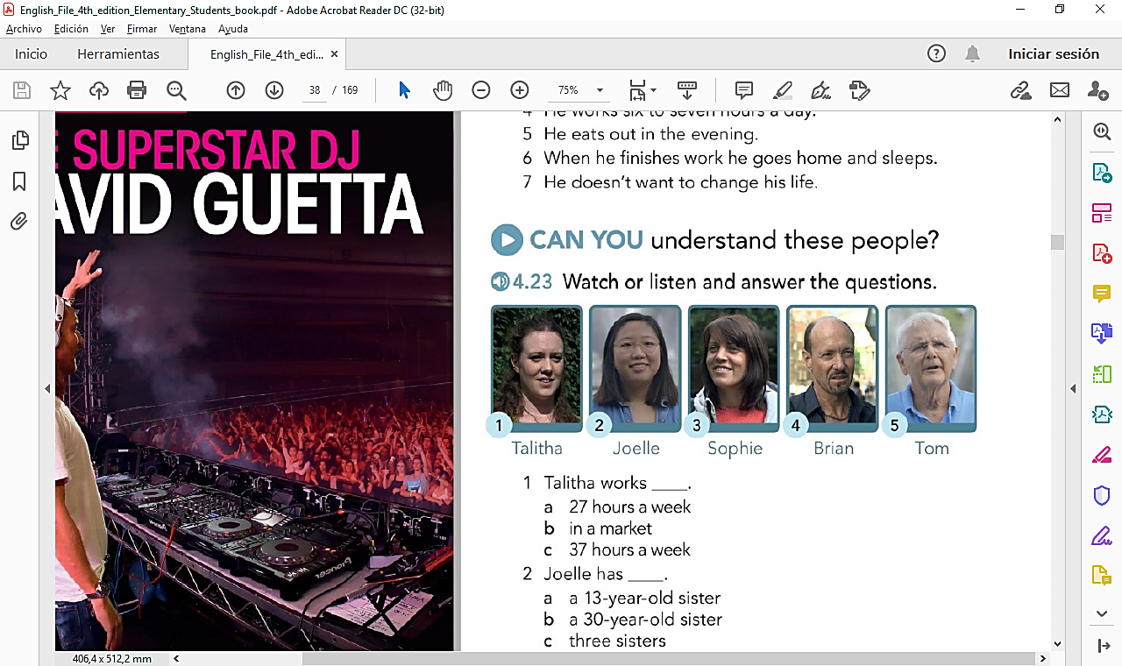

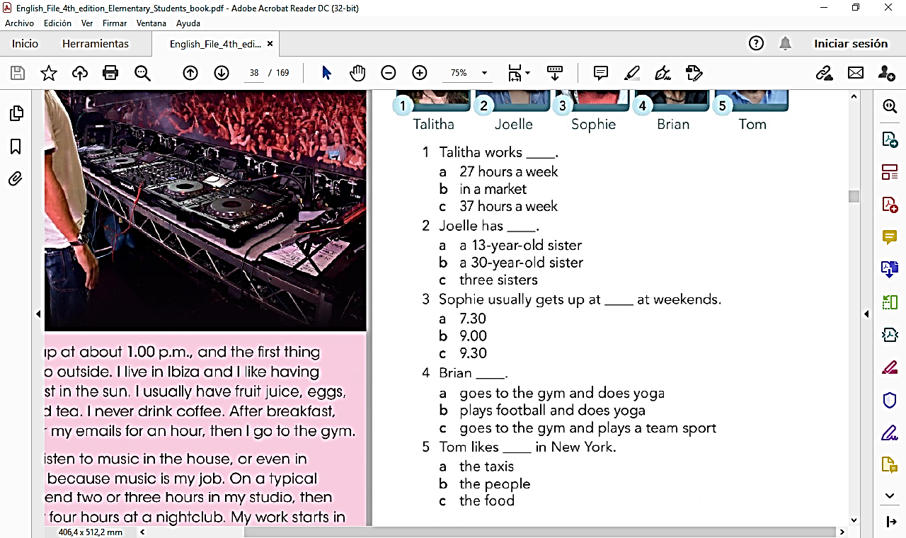

# **Reading**

1. Read the article once. What’s unusual about David Guetta’s life?

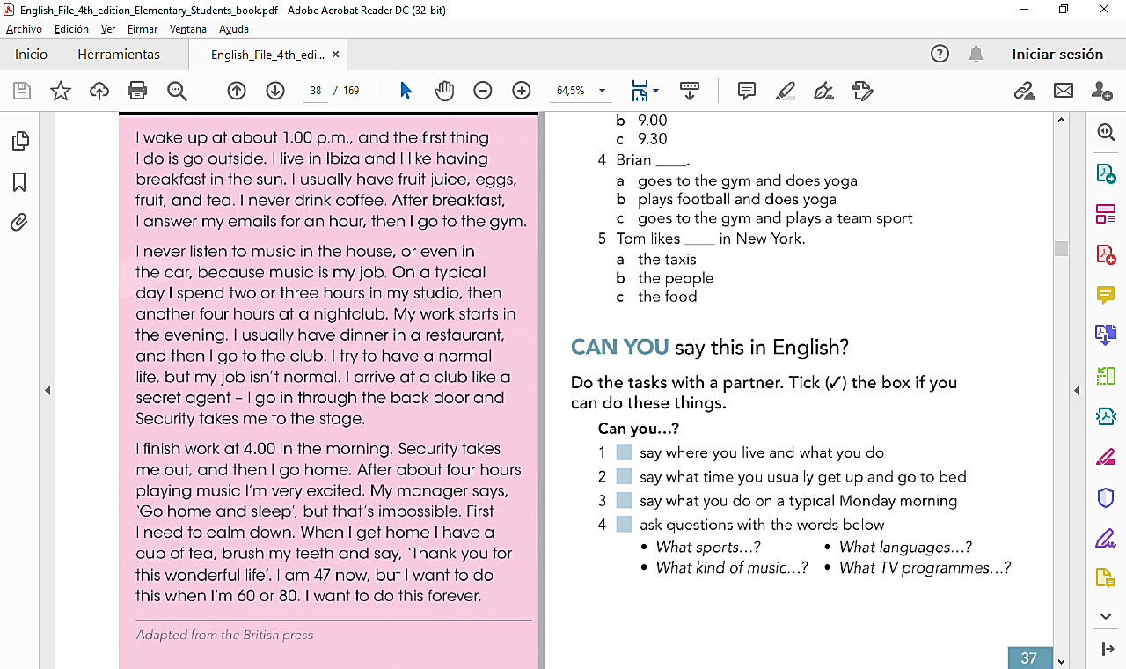

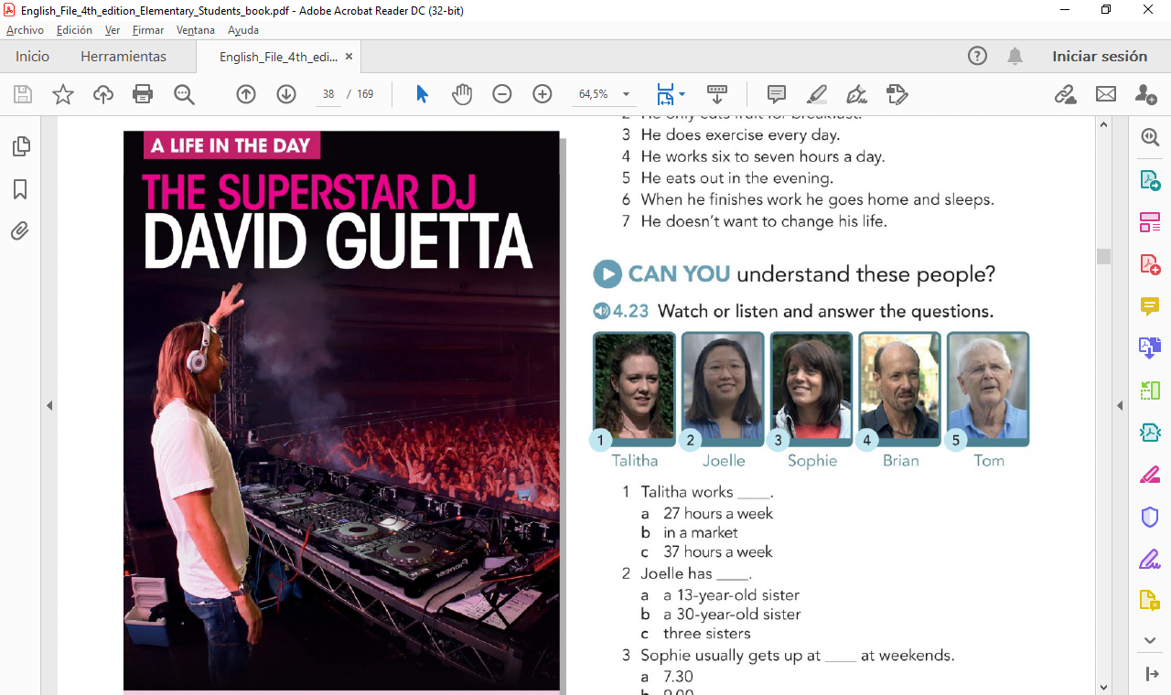

1. Read the article again. Mark the sentences **T** (true) or **F** (false)

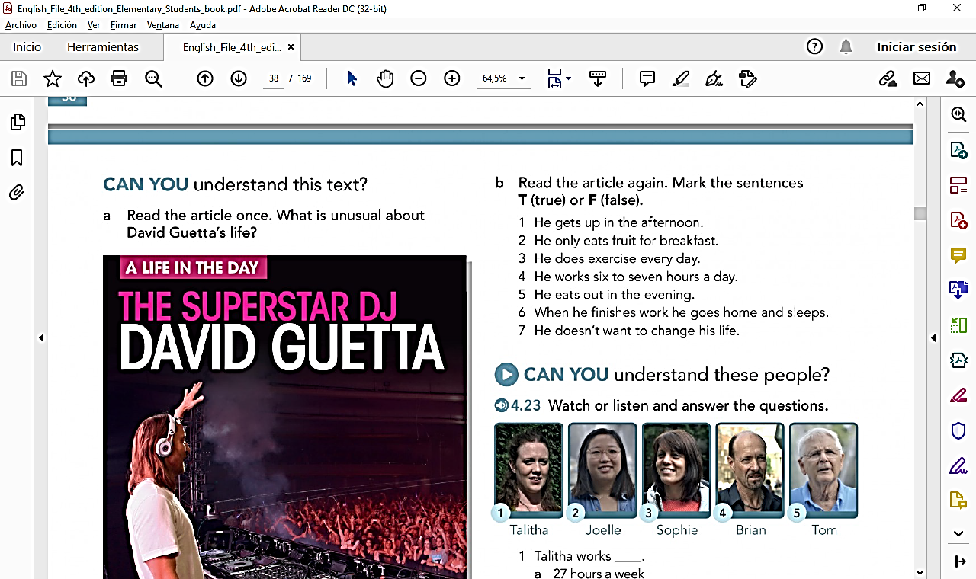

# **Pronunciation**

1. Practice the words and sounds.

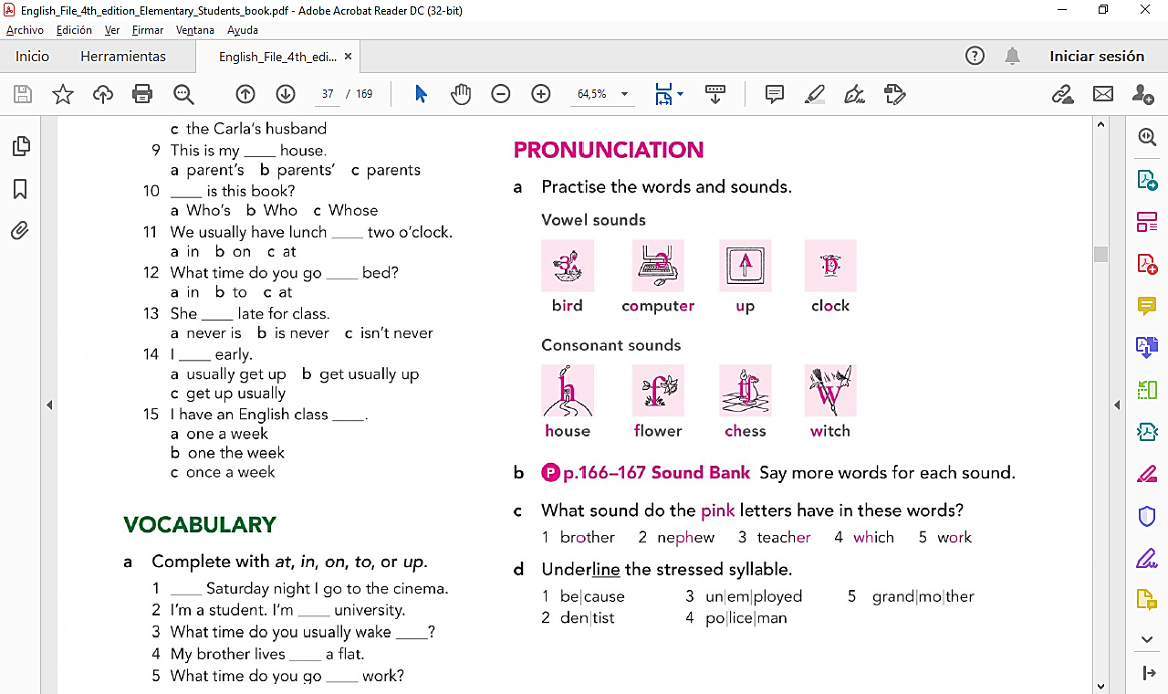

# **Progress Check**

1. 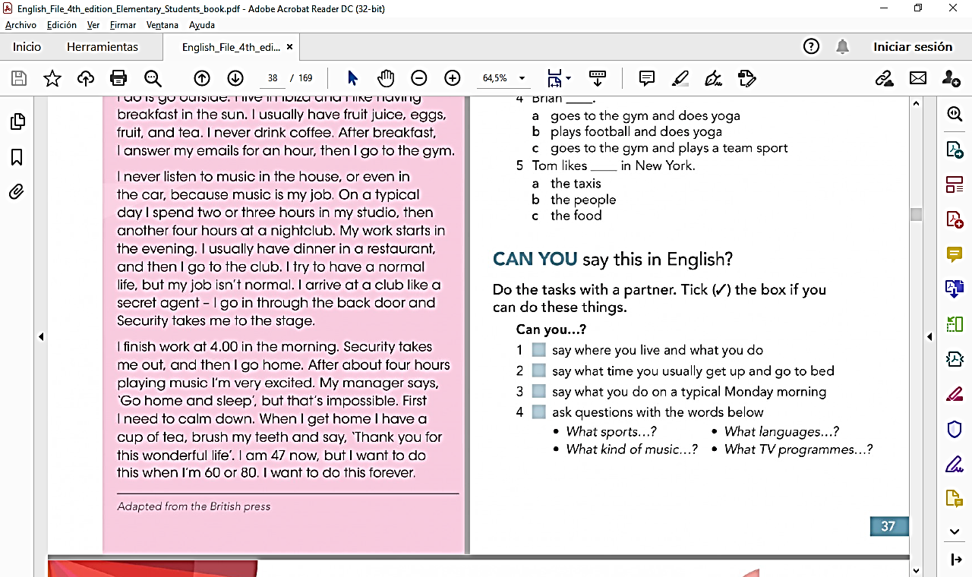Can you say this in English? Complete these tasks with a partner. Tick the box if you can do these things.

